Day 43

Life cycle of a Thread (Thread States)

In Java, a thread always exists in any one of the following states. These states are:

1. New
2. Active
3. Blocked / Waiting
4. Timed Waiting
5. Terminated

Explanation of Different Thread States

**New:** Whenever a new thread is created, it is always in the new state. For a thread in the new state, the code has not been run yet and thus has not begun its execution.

**Active:** When a thread invokes the start() method, it moves from the new state to the active state. The active state contains two states within it: one is **runnable**, and the other is **running**.

* **Runnable:** A thread, that is ready to run is then moved to the runnable state. In the runnable state, the thread may be running or may be ready to run at any given instant of time. It is the duty of the thread scheduler to provide the thread time to run, i.e., moving the thread the running state.  
  A program implementing multithreading acquires a fixed slice of time to each individual thread. Each and every thread runs for a short span of time and when that allocated time slice is over, the thread voluntarily gives up the CPU to the other thread, so that the other threads can also run for their slice of time. Whenever such a scenario occurs, all those threads that are willing to run, waiting for their turn to run, lie in the runnable state. In the runnable state, there is a queue where the threads lie.
* **Running:** When the thread gets the CPU, it moves from the runnable to the running state. Generally, the most common change in the state of a thread is from runnable to running and again back to runnable.

**Blocked or Waiting:** Whenever a thread is inactive for a span of time (not permanently) then, either the thread is in the blocked state or is in the waiting state.

For example, a thread (let's say its name is A) may want to print some data from the printer. However, at the same time, the other thread (let's say its name is B) is using the printer to print some data. Therefore, thread A has to wait for thread B to use the printer. Thus, thread A is in the blocked state. A thread in the blocked state is unable to perform any execution and thus never consume any cycle of the Central Processing Unit (CPU). Hence, we can say that thread A remains idle until the thread scheduler reactivates thread A, which is in the waiting or blocked state.

When the main thread invokes the join() method then, it is said that the main thread is in the waiting state. The main thread then waits for the child threads to complete their tasks. When the child threads complete their job, a notification is sent to the main thread, which again moves the thread from waiting to the active state.

If there are a lot of threads in the waiting or blocked state, then it is the duty of the thread scheduler to determine which thread to choose and which one to reject, and the chosen thread is then given the opportunity to run.

**Timed Waiting:** Sometimes, waiting for leads to starvation. For example, a thread (its name is A) has entered the critical section of a code and is not willing to leave that critical section. In such a scenario, another thread (its name is B) has to wait forever, which leads to starvation. To avoid such scenario, a timed waiting state is given to thread B. Thus, thread lies in the waiting state for a specific span of time, and not forever. A real example of timed waiting is when we invoke the sleep() method on a specific thread. The sleep() method puts the thread in the timed wait state. After the time runs out, the thread wakes up and start its execution from when it has left earlier.

**Terminated:** A thread reaches the termination state because of the following reasons:

* When a thread has finished its job, then it exists or terminates normally.
* **Abnormal termination:** It occurs when some unusual events such as an unhandled exception or segmentation fault.

A terminated thread means the thread is no more in the system. In other words, the thread is dead, and there is no way one can respawn (active after kill) the dead thread.

The following diagram shows the different states involved in the life cycle of a thread.

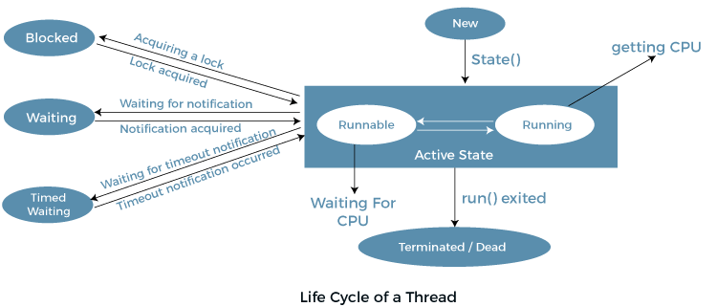

Implementation of Thread States

In Java, one can get the current state of a thread using the **Thread.getState()** method. The **java.lang.Thread.State** class of Java provides the constants ENUM to represent the state of a thread. These constants are:

**public** **static** **final** Thread.State NEW

It represents the first state of a thread that is the NEW state.

**public** **static** **final** Thread.State RUNNABLE

It represents the runnable state.It means a thread is waiting in the queue to run.

**public** **static** **final** Thread.State BLOCKED

It represents the blocked state. In this state, the thread is waiting to acquire a lock.

**public** **static** **final** Thread.State WAITING

It represents the waiting state. A thread will go to this state when it invokes the Object.wait() method, or Thread.join() method with no timeout. A thread in the waiting state is waiting for another thread to complete its task.

**public** **static** **final** Thread.State TIMED_WAITING

It represents the timed waiting state. The main difference between waiting and timed waiting is the time constraint. Waiting has no time constraint, whereas timed waiting has the time constraint. A thread invoking the following method reaches the timed waiting state.

* sleep
* join with timeout
* wait with timeout
* parkUntil
* parkNanos

**public** **static** **final** Thread.State TERMINATED

It represents the final state of a thread that is terminated or dead. A terminated thread means it has completed its execution.

# Java Threads | How to create a thread in Java

There are two ways to create a thread:

1. By extending Thread class
2. By implementing Runnable interface.

### Thread class:

Thread class provide constructors and methods to create and perform operations on a thread.Thread class extends Object class and implements Runnable interface.

### Commonly used Constructors of Thread class:

* Thread()
* Thread(String name)
* Thread(Runnable r)
* Thread(Runnable r,String name)

### Commonly used methods of Thread class:

1. **public void run():** is used to perform action for a thread.
2. **public void start():** starts the execution of the thread.JVM calls the run() method on the thread.
3. **public void sleep(long miliseconds):** Causes the currently executing thread to sleep (temporarily cease execution) for the specified number of milliseconds.
4. **public void join():** waits for a thread to die.
5. **public void join(long miliseconds):** waits for a thread to die for the specified miliseconds.
6. **public int getPriority():** returns the priority of the thread.
7. **public int setPriority(int priority):** changes the priority of the thread.
8. **public String getName():** returns the name of the thread.
9. **public void setName(String name):** changes the name of the thread.
10. **public Thread currentThread():** returns the reference of currently executing thread.
11. **public int getId():** returns the id of the thread.
12. **public Thread.State getState():** returns the state of the thread.
13. **public boolean isAlive():** tests if the thread is alive.
14. **public void yield():** causes the currently executing thread object to temporarily pause and allow other threads to execute.
15. **public void suspend():** is used to suspend the thread(depricated).
16. **public void resume():** is used to resume the suspended thread(depricated).
17. **public void stop():** is used to stop the thread(depricated).
18. **public boolean isDaemon():** tests if the thread is a daemon thread.
19. **public void setDaemon(boolean b):** marks the thread as daemon or user thread.
20. **public void interrupt():** interrupts the thread.
21. **public boolean isInterrupted():** tests if the thread has been interrupted.
22. **public static boolean interrupted():** tests if the current thread has been interrupted.

### Runnable interface:

The Runnable interface should be implemented by any class whose instances are intended to be executed by a thread. Runnable interface have only one method named run().

1. **public void run():** is used to perform action for a thread.

### Starting a thread:

The **start() method** of Thread class is used to start a newly created thread. It performs the following tasks:

* A new thread starts(with new callstack).
* The thread moves from New state to the Runnable state.
* When the thread gets a chance to execute, its target run() method will run.